**Best Place to Open a new Ice cream shop in Salvador**

**Deise Côrtes**

1. **Introduction**
   1. **Background**

Salvador is the fourth biggest city in Brazil, with 2.9 million people and about 692,818 km2.

Salvador is also a very popular tourist destination, due mainly to its history, culture and weather. Every year, especially during the Summer, over 1 million tourists come to spend some time in the city.

Salvador has 50 km of beaches. Due to the warm weather, the beaches are one of the top leisure activities for both: locals and tourists.

* 1. **Problem**

I have a friend willing to open a new Ice cream shop and I would like to recommend her a good place for it.

However, this research can be used by any businessmen willing to open a new Ice cream shop in the city.

* 1. **Interest**

The audience would be businessmen interested in exploit new opportunities at the city.

1. **Data**

* 1. **Data sources**

We assume that ice cream consumption will be higher close to the beaches.

We’ve used Foursquare to identify both: the main beaches in the city as well as the existing ice creams close to them.

This is the map of recognized beaches Salvador, provided by Foursquare:

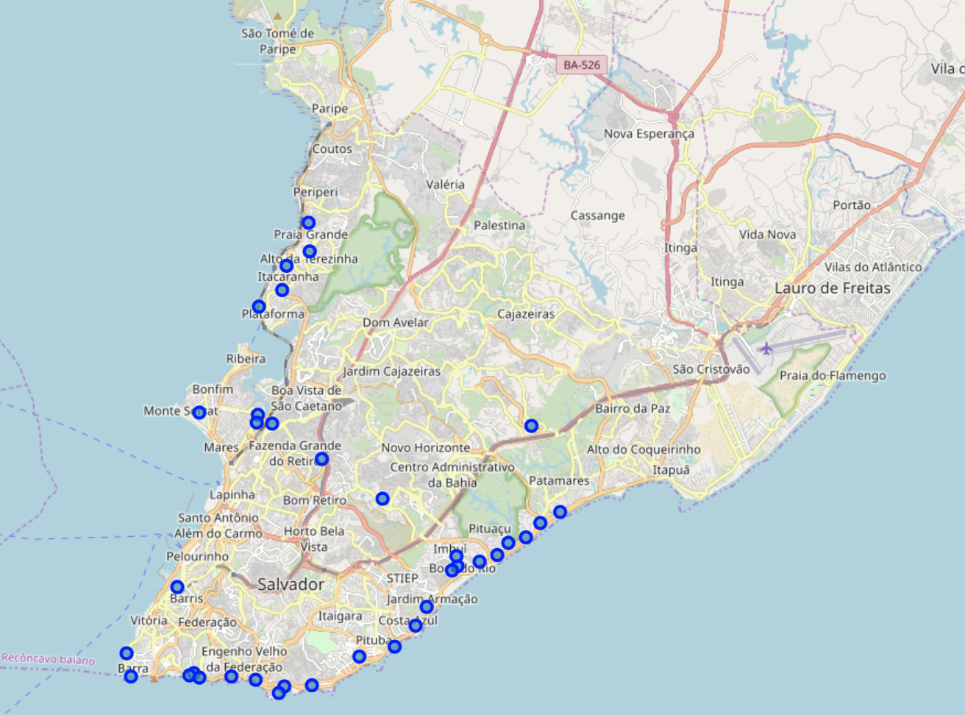

**2.2 Data Cleaning**

The json provided by Foursquare returned some venues that were not really beaches, but, instead were harbor or even restaurants.

We’ve cleaned the data in order to remove the invalid spots.

1. **Methodology**

The data frame containing the beaches of the city had 89 rows and the following features: id, name, categories, lat and lng.

Id: the venue id

Name: the name of the Beach

Categories: Beach

Lat: latitude of the venue

Lng: longitude of the venue

Here are the first 15 elements in the dataframe:

After identifying the beaches, we’ve tried to locate ice cream shops close up to 300 meters to the beach.

We’ve created a list containing the beaches lacking a close ice cream shop.

1. **Results**

Here are the list of beaches in Salvador without a close ice cream shop:

'Praia da Paciência',

'Praia de Ondina',

'Praia Madre de Deus',

'Praia Jardim de Alah',

'Praia de Amaralina',

'Praia de Armação',

'Praia da Pituba',

'Praia de Mar Grande',

'Praia de Patamares',

'Praia dos Buzios',

'Praia Da Armacao',

'Praia de Piatã',

'Praia de Pituaçu',

'Praia De Periperi',

'Praia de Itacaranha',

'Praia de Piatã',

'Praia Grande',

'Praia da 3ª Ponte',

'Praia Farol da Barra',

'Praia de Placafor',

'Praia do Alvejado',

'Praia Do Jaburu',

'Praia do Bom Despacho',

'Praia do Flamengo - Salvador',

'Praia da Penha'

1. **Conclusion**

In this study, I’ve analyzed the beaches in Salvador lacking close ice creams. First, I created a dataframe containing the beaches of Salvador and their respective latitude and longitude. Then, for each beach, I located ice cream shops close to it up to 300 meters. Finally, I created a list of beaches lacking a close ice cream shop. This is a valuable information for entrepreneurs willing to open a new ice cream shop in the city.